Mentor Application Form
Znaniye Foundation is delighted to have received funding from the BBC Children in Need's grant programme.

Over the next 3 years, we will be offering bespoke mentoring and support for local Ealing students in school years 8 through to 11.

Our goal is to work with the youth in our community, and inspiring figures to build confidence,

increase school attainment and show young people just how many wonderful prospects lay ahead in their futures.

Children and Young People in the above year groups will be able to be specifically paired with an inspirational and successful mentor, with similar lived experiences as themselves - who have achieved or are working on achieving their own life expectations.

We are looking for successful mentors, but we are not interested in standard levels of success.

We are looking for inspirational individuals, who can use their own experiences to guide young people who need support.

This may mean an individual who has overcome hardships to reach their goals, who strayed from a standard societal path to reach their success, those who are passionate about community and youth activation and more. Most of our mentors are professionals in their fields, but this is in no way compulsory.

The key attributes we are looking for are honesty, integrity, respect, confidence, responsibility, reliability, perseverance and courtesy.

The mentor needs to be committed - we are working to build a strong, reliable mentor-mentee relationship, and as such, each mentor needs to understand the significance of the role they could play in this young person's life.

Mentors will need to be available bi-weekly for hour-long 1-2-1 sessions, online, with their personal matched mentee.

They will work with their mentee to set goals, give guidance, and inspire them. They will work to understand their weaknesses and how to overcome them, and their strong points and how they can capitalise on them. We are here to show these young people in our community, just how capable they are, despite hardships they may be facing.

Full Name
Preferred Name
Date of Birth
Home Address
Email Address
Phone Number
Place of Work
Job Role

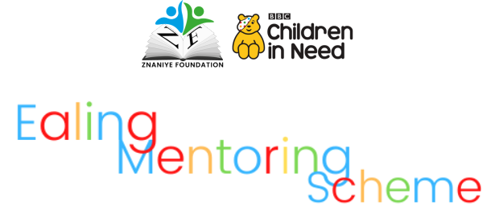

A Bit About You:

This is where we want to know a little bit more about you, your journey in life so far, and why you think you could be a mentor to one of our young people.

Please tell us a little bit about your job, and how you got to your role:

Here we would like to know a little about your hobbies and interests, outside of your job:

What skills do you think you can bring to a programme like ours?

Do you have any lived experiences that you feel children referred to this programme could relate to? (You do not have to disclose anything you do not wish to)

Is there anything else you would like to mention?

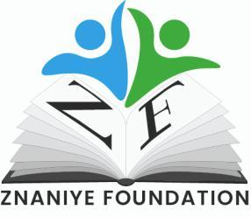

Thank you very much for your interest in participating in this programme.

All your information will be kept entirely private and secure by our team.

The next stage will be an internal review by our team, should we feel that you can fit the role, we will organise a short zoom call with you to talk a little bit more about the programme.

Please sign below to confirm the above information is true:

Full Name:

Date:

Signature:

Znaniye Foundation is a registered UK charity

Charity Number 1101796

www.znaniyefoundation.co.uk

contact@znaniyefoundation.co.uk

