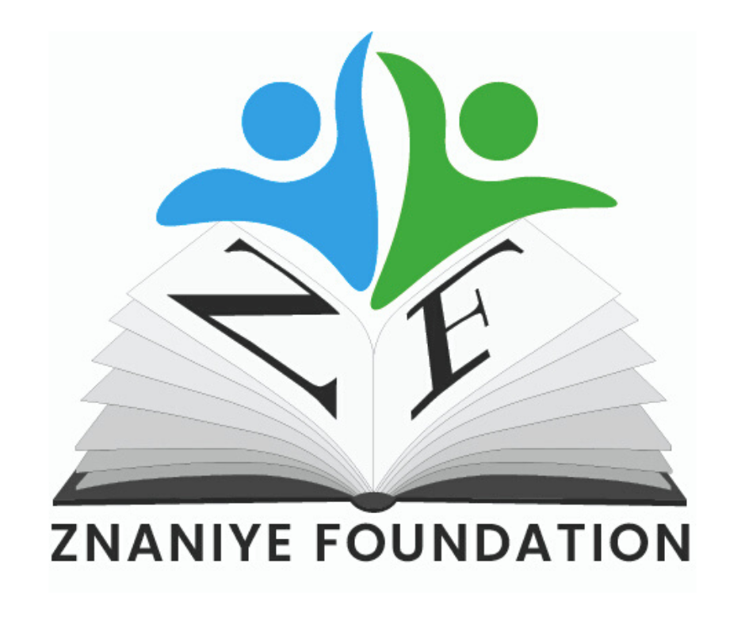
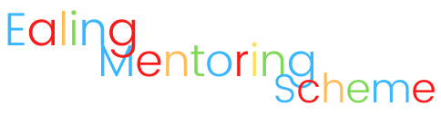

Self Referral Form

They are many reasons why you might feel you can benefit from this project and would like to put yourselves forward. It may be that you are struggling to find a path for your future education or career, those struggling to integrate back into school after school closures during Covid, those from low-income households who would benefit from access to new experiences and confidence-building and many more.

If you are under 16, please ensure that you have full parental/guardian consent to submit your application

Please note that our team, volunteers and mentors are all fully DBS checked and trained in line with UK Ofsted, Charity, and BBC Children in Need Standards, and all your information is kept secure and private

Name of Student
Student Date of Birth
Current Year Group
Current School Name
Contact Email
Contact Phone Number
Student Date of Birth
Current Year Group
Do you fall into any of the following categories?  Please circle if so | FREE SCHOOL MEALS  BAME  Looked After Child (Foster Care)  Recent UK arrival or refugee  SEND (Special Education Needs or Disabilities)
Why do you feel that you could personally benefit from our programme? i.e. 1-2-1 mentoring with a successful figure, school and wellbeing support and more. Please include
struggles you feel you are facing that we could help solve.
What are the specific areas that you could use the most support in? I.e. Confidence building/self-worth, understanding educational or job options in your future, goal setting or
other.
Our mentoring typically takes place online, to work around students school times, and for the schedules
of our mentors - do you have access to a device and internet?
If possible, we would like to hear from the student, about why they want to take part in the
programme too (not compulsory)
Do you have the parent/guardian’s permission to submit your information? (under 16’s only)
And finally, is there anything else you would like to mention to us?
Date
Student Full Name
Signature

Please return your form to contact@znaniyefoundation.co.uk,
with the subject line 'Ealing Mentoring Self Referral’

If you have any questions at all, please get in touch with us

ZNANIYE FOUNDATION
REGISTERED CHARITY 1101796
WWW.ZNANIYEFOUNDATION.CO.UK
@ZnaniyeFoundation

